Specification of software requirements

Subjec: Recognition of Plates

 |  | January 2021

Date | Review | Description | Author
12/01/2020 |  |  | Cortez Jonathan  Coyago Eunice  Cují Roberto  Garcés Christian  Guerra Luciana

Content
Document file 3
Contents 4
1 Introduction 6
1.1 Purpose 6
1.2 Scope 6
1.3 Involved personnel 6
1.4 Definitions, acronyms and abbreviations 6
1.5 References 6
1.6 Summary 6
2 Overview 7
2.1 Product perspective 7
2.2 Product functionality 7
2.3 User characteristics 7
2.4 Restrictions 7
2.5 Assumptions and dependencies 7
2.6 Predictable evolution of the system 7
3 Specific requirements 7
3.1 Common interface requirements 8
3.1.1 User interfaces 8
3.1.2 Hardware interfaces 8
3.1.3 Software interfaces 8
3.1.4 Communication interfaces 8
3.2 Functional requirements 8
3.2.1 Functional requirement 1 9
3.2.2 Functional requirement 2 9
3.2.3 Functional requirement 3 9
3.2.4 Functional requirement n 9
3.3 Non-functional requirements 9
3.3.1 Performance requirements 9
3.3.2 Safety 9
3.3.3 Reliability 9
3.4 Other requirements 10
4 Appendices 10

Introduction
Our vision is to carry out a program which allows us to recognize license plate numbers, based on a photograph, through a txt database that will inform us if the known license plate is accepted for entry or not.
.

Purpose

1.1.1 Automatically identify alphanumeric characters from an image.

1.1.2. Convert the text that appears in an image into a text file, generating an input confirmation.

1.1.3. Digitize the information.

Scope
The purpose of this document is to define the functional and non-functional specifications for the development of a license plate recognition system that will allow vehicle access to a parking place, this system will be used by students, teachers and managers.

Involved personnel

Name | Cortez Tamayo Jonathan Andrés
Role | Designer and programmer
Professional category | IT engineering student
Responsibilities | Desing and programming of the PRP
Contact information | jacortez3@espe.edu.ec

Name | Coyago Arce Eunice Pamela
Role | Designer and programmer
Professional category | IT engineering student
Responsibilities | Desing and programming of the PRP
Contact information | epcoyago@espe.edu.ec

Name | Cují Revelo Milton Roberto
Role | Designer and programmer
Professional category | IT engineering student
Responsibilities | Desing and programming of the PRP
Contact information | mrcuji@espe.edu.ec

Name | Garcés Mosquera Chistian Marce
Role | Designer and programmer
Professional category | IT engineering student
Responsibilities | Desing and programming of the PRP
Contact information | Cmgarces2@espe.edu.ec

Name | Guerra López Luciana Noemi
Role | Designer and programmer
Professional category | IT engineering student
Responsibilities | Desing and programming of the PRP
Contact information | lnguerra@espe.edu.ec

1.4 Definitions, acronyms and abbreviations
Name | Description
PRP: | Plate Recognition Program
User: | Person who will use the system to manage processes

1.5 References
Reference | Title | Route | Date | Author

Summary
This project wishes to establish the use of technology through image recognition, to solve certain problems that are established in people's daily lives, the same that helps to facilitate certain actions and avoid wasting time, as well as the security issue Of the same. Optical character recognition is a text recognition process in most cases it is focused on the digitization of texts through an image, for this it is necessary that they are within the alphabet that is going to be used. From an image, a program will be implemented that allows recognizing characters, this information will be processed and stored in a text file to later be used or implemented in the automation of data entry in a text file, which implies a saving of human resource required for this action in order to improve or implement a service.
This project is limited to a parking lot which will help to recognize the license plates of each car when entering or leaving a parking lot and in turn recognize it in its database.

General description

Product perspective
The system establishes an image treatment which can be treated and dimensioned, in order to understand the text that it is composing, taking as an example a car license plate, which we can determine which license plate is and this text can be treated and the programming language I can understand it and it will pass to a string.

.

Product functionality
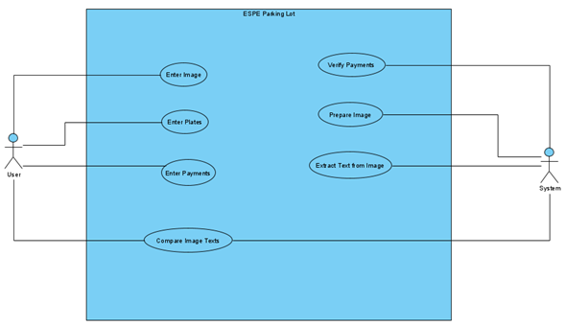

User characteristics

Type of user | Average person
Training | Basic technological knowledge
Activities | Enter information into the system

.
Type of user | Student
Training | Academic
Activities | School activities
Type of user | Educator
Training | Professional
Activities | Teaches

Restrictions
- The must be a camera connected for the program to work
- The program was designed for an environment with cars
- Language and use of technologies: Java
- The system must have a small database

Assumptions and dependencias
- The requirements described here are assumed to be stable
- The computers on which the system will be run must meet the requirements indicated above to guarantee a correct execution of the same.

Specific requirements

Requirement number | 1
Requirement name | User authentication
Characteristic | Users must identify themselves to access the system
Description of the requirement | The system can be consulted by any user depending on their level of accessibility
Requeriment priority | High

Common interface requirements

User interfaces
The user interface will consist of a set of text fields. This must be built specifically for the proposed system and will be viewed from a screen.

Hardware interfaces
- camera
- mouse
- keyboard
- Computer
.

Software interfaces
- Operating System: Windows XP or higher
- Explorer: Mozilla or Chrome.

Communication interfaces
Servers, clients and will communicate with each other, using standard internet protocols, whenever possible.

.

Functional requirements

Functional requirement 1

User authentication: users must be identified to save them in the system.The user must provide data such as:, Name, Surname, User and Password, plates

Non-functional requirements

Performance requirements
Ensuring that the design of the queries or plate scan or other process does not affect the performance of the database.

Security
- Guarantee the reliability, security and performance of the computer system to the different users.
- Guarantee the security of the system with respect to the information and data that are handled such as documents, files.
- Facilities and controls to allow access to information to authorized personnel, with the intention of consulting and uploading pertinent information for each of them

Reliability
- The system must have an intuitive and simple user interface
- The user interface must conform to the characteristics of the institution, within which the - The system will be incorporated.

.

Other requirements

Appendices

